Statement of Faith

Leader: We affirm our faith in the Bible
Congregation: We believe the Bible to be the inspired and only infallible word of God.
Leader: We affirm our faith in God.
Congregation: We believe that there is one God, eternally existent in three persons -- God the Father, God the Son and God the Holy Spirit.
Leader: We affirm our faith in the Blessed Hope.
Congregation: We believe in the blessed hope, which is the rapture of the Church of God by Jesus Christ at his return.
Leader: We affirm our faith in Repentance.
Congregation: We believe that the only means of being cleansed from sin is through repentance, faith in the precious Blood of Jesus Christ and being baptized in water.
Leader: We affirm our faith in Salvation.
Congregation: We believe that regeneration by the Holy Ghost is absolutely essential for personal salvation.
Leader: We affirm our faith in Jesus Christ.
Congregation: We believe that the redemptive work of Christ on the cross provides healing for the human body in answer to believing prayer.
Leader: We affirm our faith in the Holy Spirit.
Congregation: We believe that the baptism in the Holy Ghost, according to Acts 2:4 is given all believers who ask for it.
Leader: We affirm our faith in Sanctification.
Congregation: We believe in the sanctifying power of the Holy Spirit, by whose indwelling, the Christian is enabled to live a holy and separated life in this present world; Amen

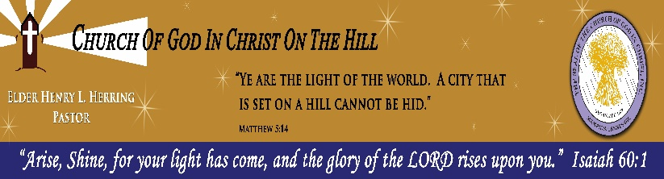

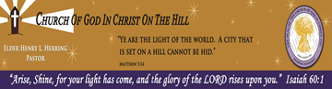

4th Sunday
Men In Charge Worship Service
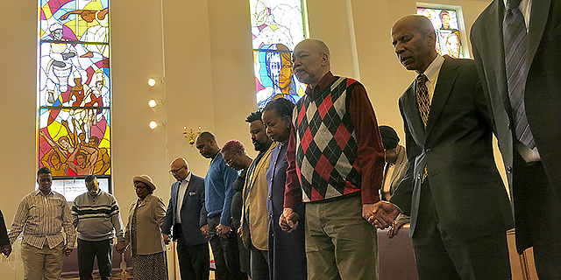
“Stand Upon Thy Feet, and I will Speak Unto Thee”
(Ezekiel 2:1)

Church of God In Christ On The Hill Cathedral
Sunday Service
June 25, 2023
11:30 A.M.
137 Buffalo Avenue
Brooklyn, New York 11213

Elder Henry Herring, Pastor

Face Masks Must Be worn at All Times During Service

Order of Service
Expeditor: Deacon Alexander Brent, Sr.
Call to Worship………………………………………………………..
Invocation……………………………..…Pastor Henry Herring, Sr.
Scripture………………………………..Minister Lawrence Reeder
Hymn.............................................................”Hold To His Hand”
Statement of Faith………………………Minister Tyrone Sherrod
Acknowledgments/Bulletin……………………..Brother Alexander Brent, II
Ministry of Giving (Tithing/ Offering) ….…………..………Financiers
Introduction of Speaker……………Deacon Alexander Brent, Sr.
Musical Selection…………………...…..……….….…….......Choir
The Lord's Message…………………..…………Elder Ryan Dash
Remarks and Benediction…..…………Pastor Henry Herring, Sr.

Services are Subject to Change

The church website is www.cogicoth.org

Face Masks Must Be worn at All Times During Service
WEEKLY SCHEDULE
SUNDAYS
Sunday School | 10:00 a.m.
Sunday Worship | 11:30 a.m.
Women In Charge Worship Service | 2nd Sunday
Holy Communion | 3rd Sunday
Men In Charge Worship Service  Youth In Charge Worship Service | 4th Sunday  5th Sunday
TUESDAYS

Touch & Agree Noon Day Prayer via Phone Conference Call 12:00 p.m.
WEDNESDAY

Bible Study via Phone Conference Call 7:30 p.m.

FRIDAYS
Food Ministry- Grab and Go Hot-meal & Food Pantry hosted by Mother Evelyn Lucas
Church Members ........................................................11 am
General Public…………………………….....................12 pm
Pastoral Night Service………………………………...7:30 pm
PRAYER REQUESTS:

We are continuously praying for all sick and shut-in and families who are in bereavement and Our Nation.
BULLETIN BOARD:

7/9/23: 2nd Sunday, Women In Charge (WIC) Worship Service. The Speaker will be Evangelist Tabitha Smith.

Reminder: Class Dues are due the 1st Sunday of every month. Please see your Class Leader. Class 1: Deaconess Barbara Sowells, Class 2: Deacon Alexander Brent, Sr., Class 3: Sister Marion Gallop-Alexis.

Givelify Donations Are Now Available to Church of God in Christ On the Hill. You will see Pastor Henry L. Herring, Sr.’s picture. Pay Credit/Debit.

e

